**LBP**

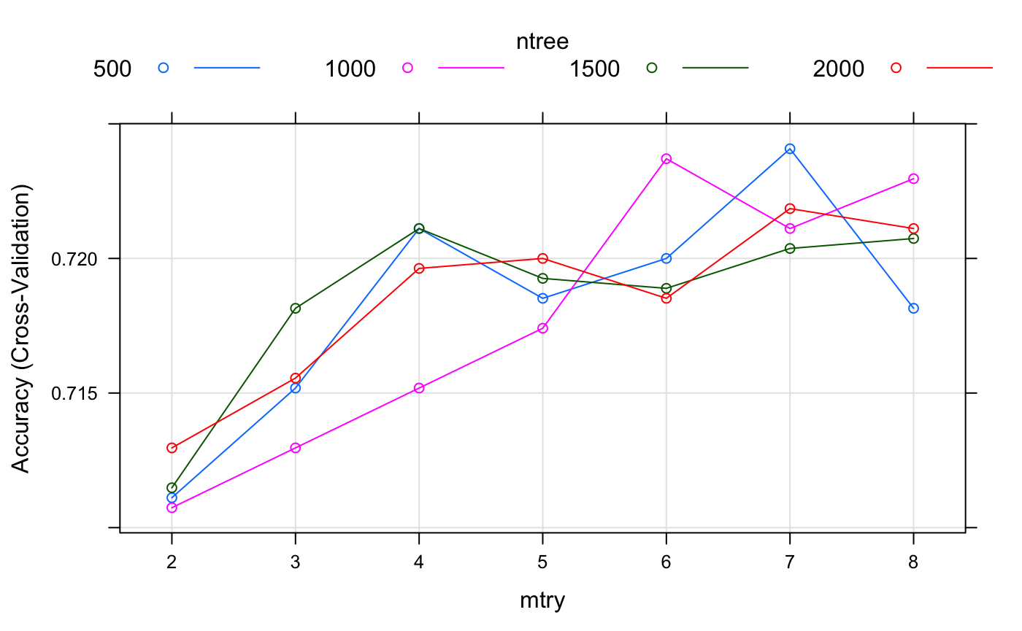

**HOG**

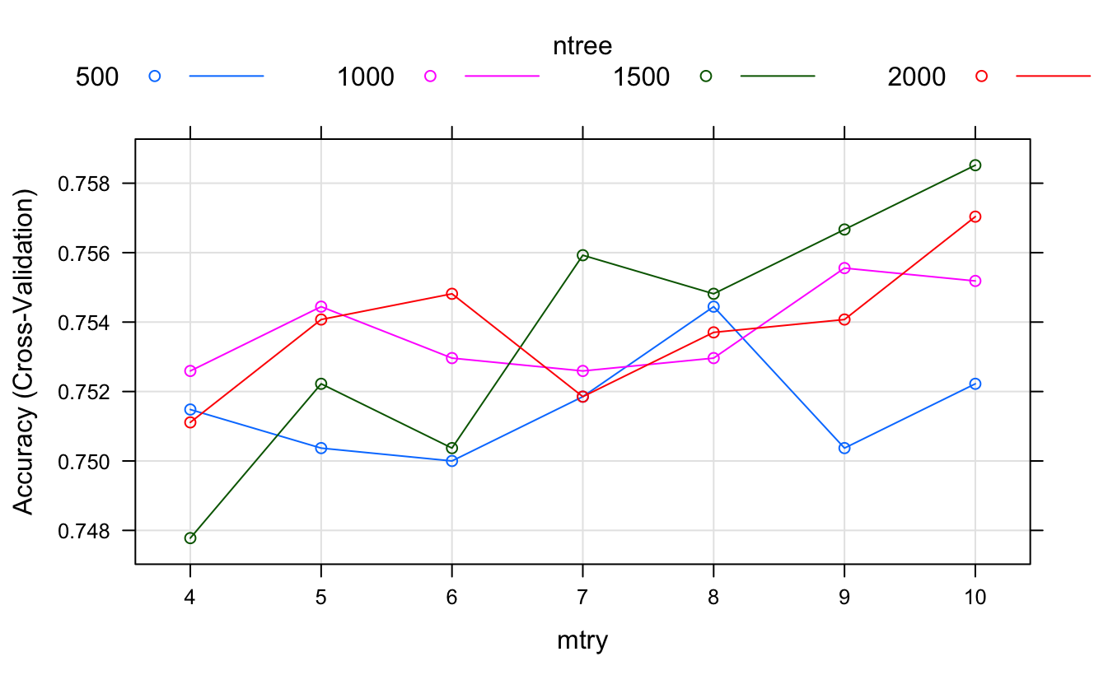

**SIFT**

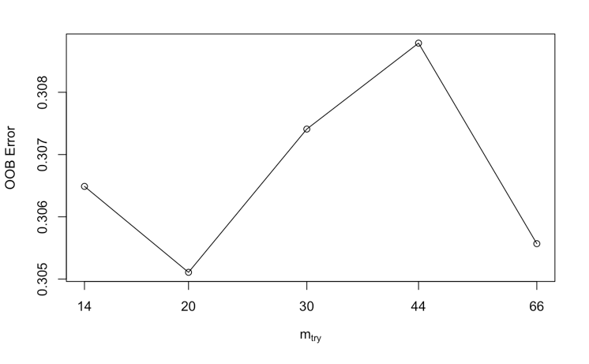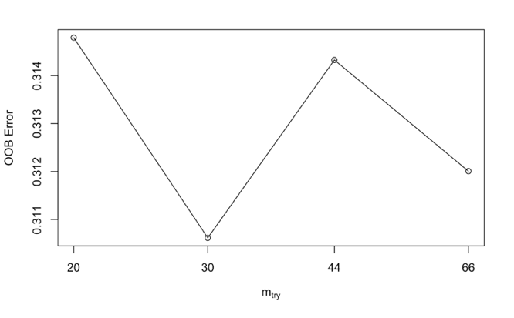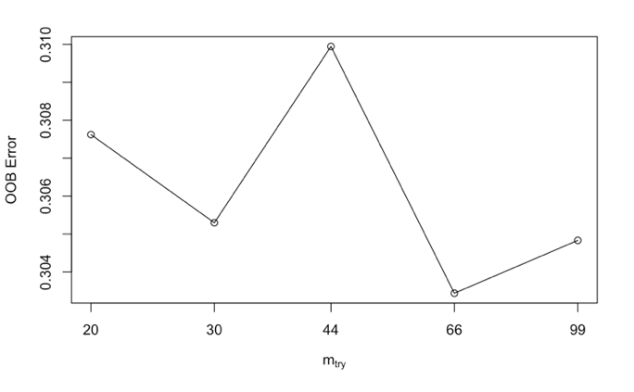

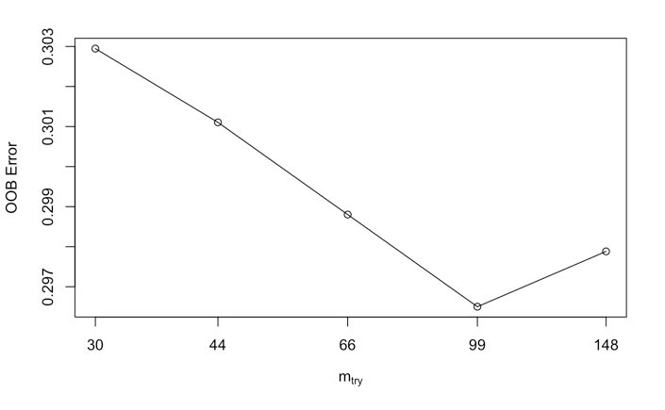 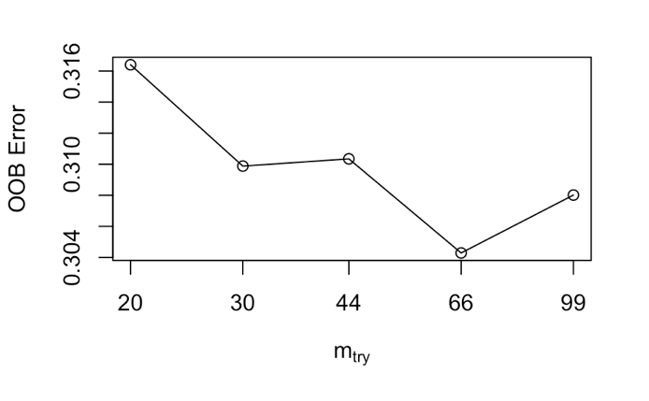

**GIST**

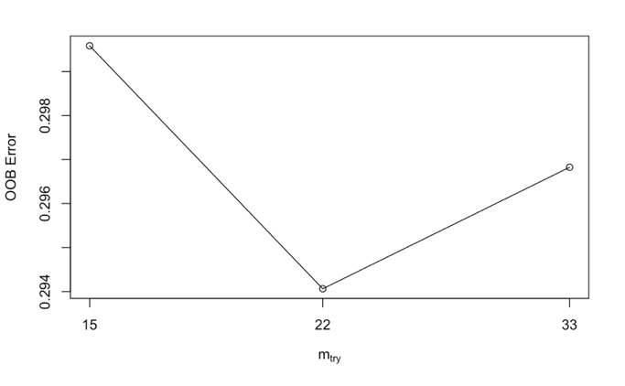 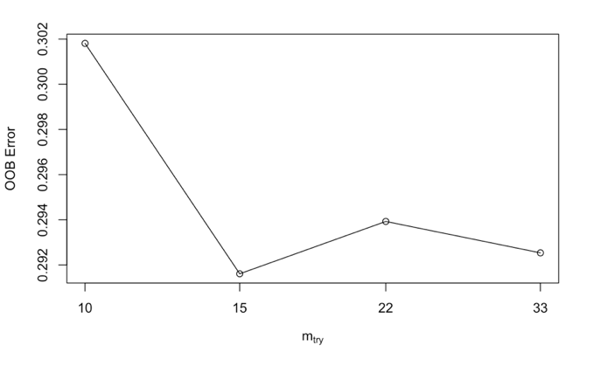 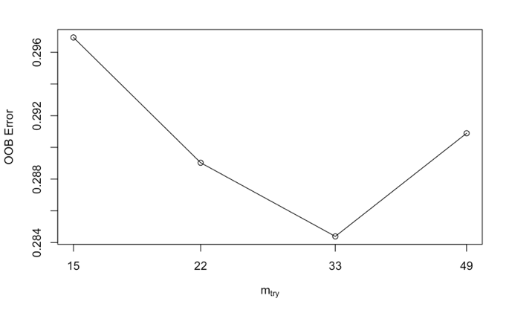 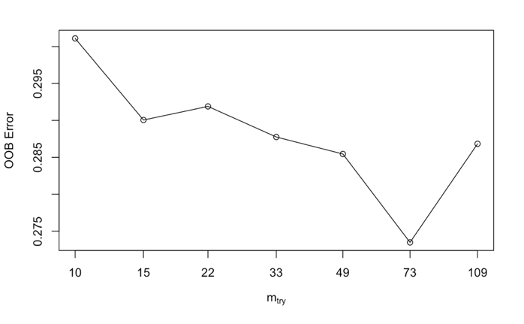 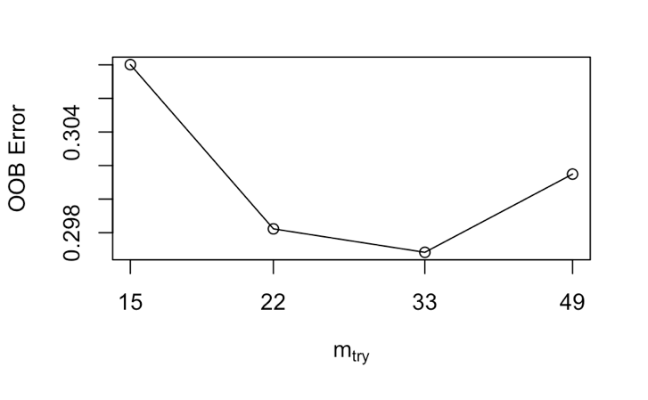

|  |  |  |  |  |  |
| --- | --- | --- | --- | --- | --- |
|  | | Customerized RF | | tuneRF() | |
|  | | HOG | LBP | GIST | SIFT |
| ntree | | 1500 | 500 | 600 | |
| mtry | | 10 | 7 | 33 | 66 |
| Training time | user | 28.987 | 5.424 | 107.004 | 618.718 |
| system | 1.092 | 0.138 | 0.447 | 1.686 |
| elapsed | 32.963 | 6.447 | 107.940 | 622.495 |
| Test Error | | 0.2533 | 0.2867 | 0.28 | 0.2633 |